<!DOCTYPE html>

<html lang="en">

<head>

    <meta charset="UTF-8">

    <meta name="viewport" content="width=device-width, initial-scale=1.0">

    <title>Document</title>

    <link rel="stylesheet" href="style.css">

    <link href="https://fonts.googleapis.com/css2?family=Bungee&family=Rubik:wght@400;500;700&display=swap" rel="stylesheet">

</head>

<body style="background-color: #f4f4f4;">

    <header class = "main-header">

    <h1>

      Design Classification

    </h1>

  </header>

  <!--Animaliaaaaaa-->

  <section class ="container">

    <div class = "div-table">

        <table class="table">

            <thead class ="table-headers">

                <tr>

                    <th>ANIMALS</th>

                </tr>

            </thead>

            <tbody class = "table-body">

                <tr>

                    <td>Ape</td>

                </tr>

                <tr>

                    <td>Cat</td>

                </tr>

                <tr>

                    <td>Cheetah</td>

                </tr>

                <tr>

                    <td>Dog</td>

                </tr>

            </tbody>

        </table>

    </div>

    <!--Countries-->

    <div class = "div-table">

        <table class="table">

            <thead class ="table-headers">

                <tr>

                    <th>COUNTRIES</th>

                </tr>

            </thead>

            <tbody class = "table-body">

                <tr>

                    <td>Australia</td>

                </tr>

                <tr>

                    <td>Denmark</td>

                </tr>

                <tr>

                    <td>Japan</td>

                </tr>

                <tr>

                    <td>Myanmar</td>

                </tr>

            </tbody>

        </table>

    </div>

    <!-- Food -->

    <div class = "div-table">

        <table class="table">

            <thead class ="table-headers">

                <tr>

                    <th>FOOD</th>

                </tr>

            </thead>

            <tbody class = "table-body">

                <tr>

                    <td>Almonds</td>

                </tr>

                <tr>

                    <td>Dragon Fruit</td>

                </tr>

                <tr>

                    <td>Jelly</td>

                </tr>

                <tr>

                    <td>Marshmallow</td>

                </tr>

            </tbody>

        </table>

    </div>

    <!-- Months -->

    <div class = "div-table">

        <table class="table">

            <thead class ="table-headers">

                <tr>

                    <th>MONTHS</th>

                </tr>

            </thead>

            <tbody class = "table-body">

                <tr>

                    <td>January</td>

                </tr>

                <tr>

                    <td>June</td>

                </tr>

                <tr>

                    <td>August</td>

                </tr>

                <tr>

                    <td>November</td>

                </tr>

            </tbody>

        </table>

    </div>

  </section>

</body>

</html>

**CSS**

body {

    font-family: 'Rubik', sans-serif;

    background-color: #f0f2f5;

    padding: 20px;

}

.main-header {

    position: relative;

    margin: 20px auto;

    text-align: left;

    background-color: #34495E;

    color: #f4f4f4;

    padding: 30px;

    border-radius: 1.5rem;

    border-bottom: 5px solid #1ABC9C;

    box-shadow: 0 4px 12px rgba(0, 0, 0, 0.3);

    max-width: 90%;

}

.main-header h1 {

    font-family: 'Bungee', cursive;

    font-size: 2.5rem;

    letter-spacing: 1px;

    text-transform: uppercase;

}

.container {

    margin-top: 20px;

    display: flex;

    flex-wrap: wrap;

    gap: 30px;

    justify-content: center;

    padding: 20px;

}

.div-table {

    background-color: #f4f4f4;

    width: 500px;

    padding: 25px;

    margin: 10px;

    box-shadow: 0px 4px 12px rgba(0, 0, 0, 0.3);

    border-radius: 15px;

    border-top: 5px solid #E74C3C;

    border-bottom: 5px solid #27AE60;

    border-left: 5px dashed #34495E;

    border-right: 5px double #34495E;

    transition: transform 0.3s, background-color 0.3s;

}

.div-table:hover {

    transform: scale(1.03);

    background-color: #f9f9f9;

    cursor: pointer;

}

/* Table styling */

.table {

    width: 100%;

    border-collapse: collapse;

}

.table thead {

    background-color: #2C3E50;

}

.table  th {

    font-size: 20px;

    font-weight: bold;

    color: white;

    padding: 10px;

    text-align: left;

}

.table td {

    font-size: 18px;

    color: #2C3E50;

    padding: 10px;

    background-color: #f4f4f4;

}

**OUTPUT**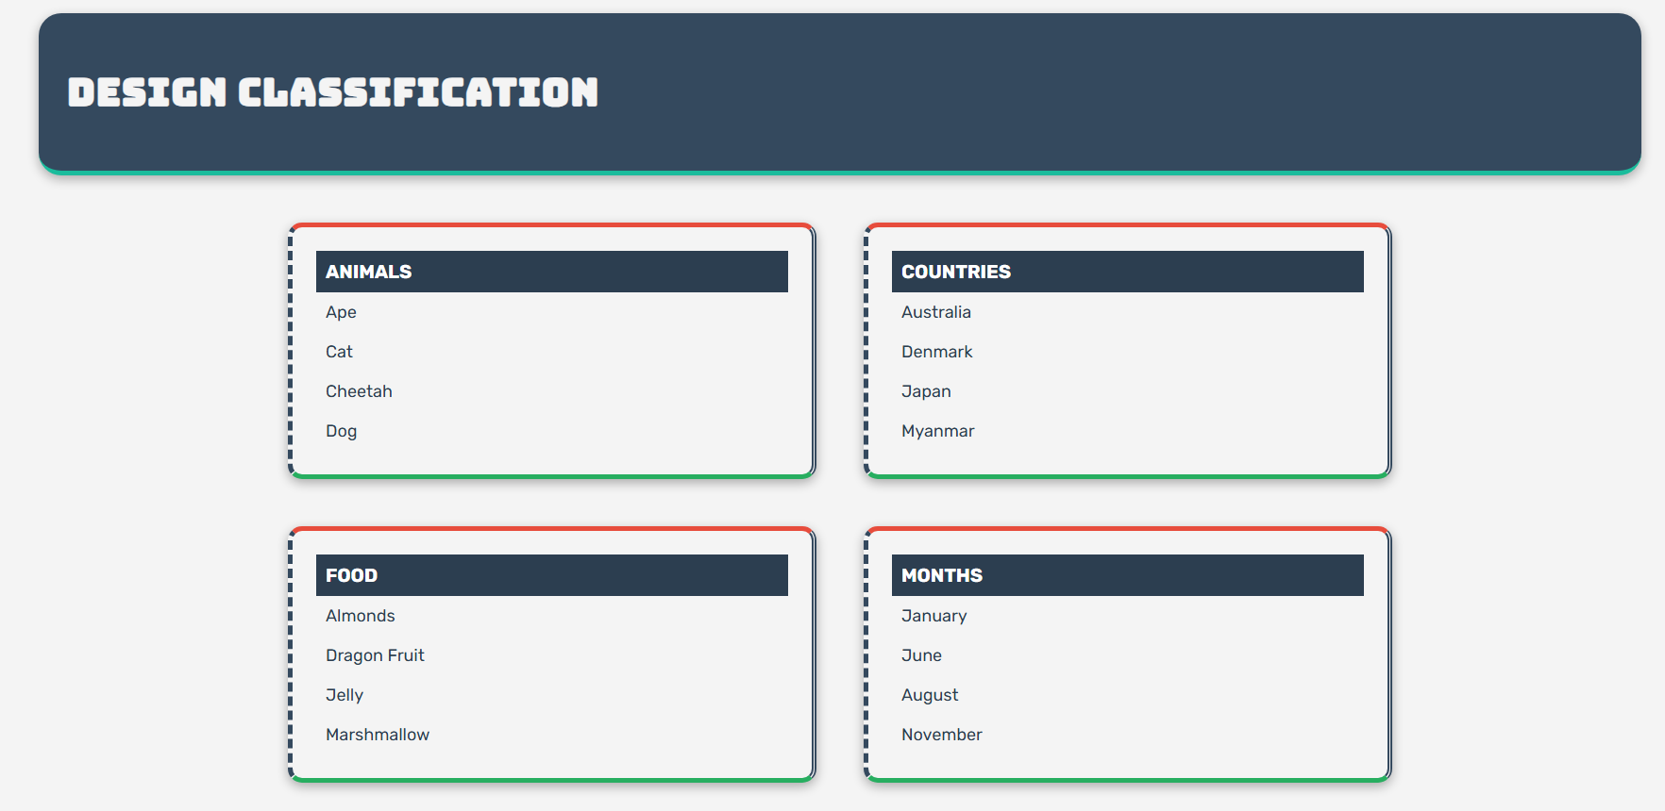

**REFLECTION**

In my webpage, I made sure to use the CSS box model consistently by setting equal width, padding, and margin for all four category containers. This helped the layout look clean and organized, with each box being the same size and having enough space around it. I used an external CSS file (style.css) to keep all my styling separate from the HTML, which made it easier to focus on structure in the HTML and just deal with design in one place. For the borders, I followed the instructions by applying different colors to the top and bottom borders and using two different styles for the left and right borders—which actually made the boxes look more creative and visually unique.

I used semantic HTML tags like <header> and <section> to give the page proper structure and meaning, and I grouped all the categorized items logically into tables within <div>s. I also made sure the layout was visually balanced using Flexbox, which kept everything aligned and spaced evenly even when the screen size changes. To add some interaction, I used a :hover effect that slightly zooms in the boxes when you hover over them, which I think makes the page feel more dynamic.

One thing I added on my own was the custom font—I searched for a font that fit the style I wanted and linked 'Rubik' and 'Bungee' from Google Fonts. That part was fun because it really changed the feel of the design. Overall, I learned a lot from doing this project, especially about borders and layout, and I enjoyed being able to personalize the look of the page.